**From:** David Reifman   
**Sent:** Friday, May 03, 2019 9:35 AM  
**To:** Steve Berlin  
**Subject:** FW: Thursday, May 2 Cinco de Mayo CelebrInvitation from Cabrera Capital Markets

Steve – I attended this event.

**From:** Martin Cabrera <[mcabrera@cabreracapital.com](mailto:mcabrera@cabreracapital.com)>   
**Sent:** Monday, April 15, 2019 2:22 PM  
**To:** David Reifman <[David.Reifman@cityofchicago.org](mailto:David.Reifman@cityofchicago.org)>  
**Subject:** Thursday, May 2 Cinco de Mayo CelebrInvitation from Cabrera Capital Markets

Please join us on Thursday, May 2 to celebrate Cinco de Mayo.

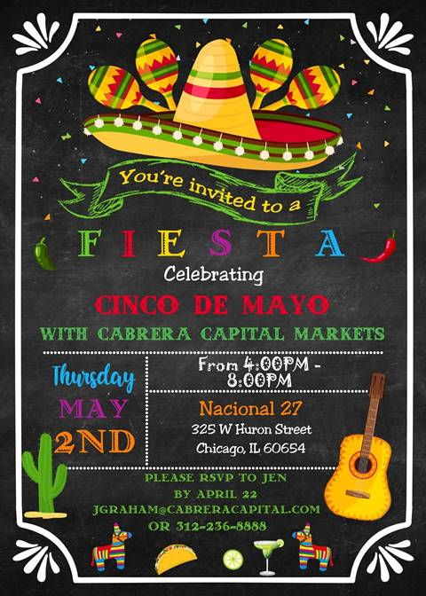

Best,

Martin

Martin Cabrera, Jr.

Chief Executive Officer

Cabrera Capital Markets, LLC